CIS7 Unit 10 Rev1 Lab: Graphs in C++ Programming.
In this lab activity, we will use C++ programming to examine the adjacency list and matrices of 2-D graphs as explained in Chapter 16. See Chapter 16 notes for more information on graphs, vertices, and matrix.
In the below graph 1, 5 vertices are displayed: 0, 1, 2, 3, 4
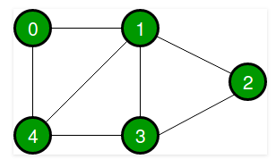
Graph 1: Undirected simple graph
- Refer to the above Graph 1 and complete the following tasks:
- Identify the vertices and the edges.

- Create an adjacency list.

- Create an adjacency matrix
Vertex | 0 | 1 | 2 | 3 | 4
1
2
3
4

std::vector::push_back
Adds a new element at the end of the vector, after its current last element. The value content is copied (or moved) to the new element.
This effectively increases the container size by one, which causes an automatic reallocation of the allocated storage space if -and only if- the new vector size surpasses the current vector capacity.
Example 1: C++ program to present simple graph using vector.
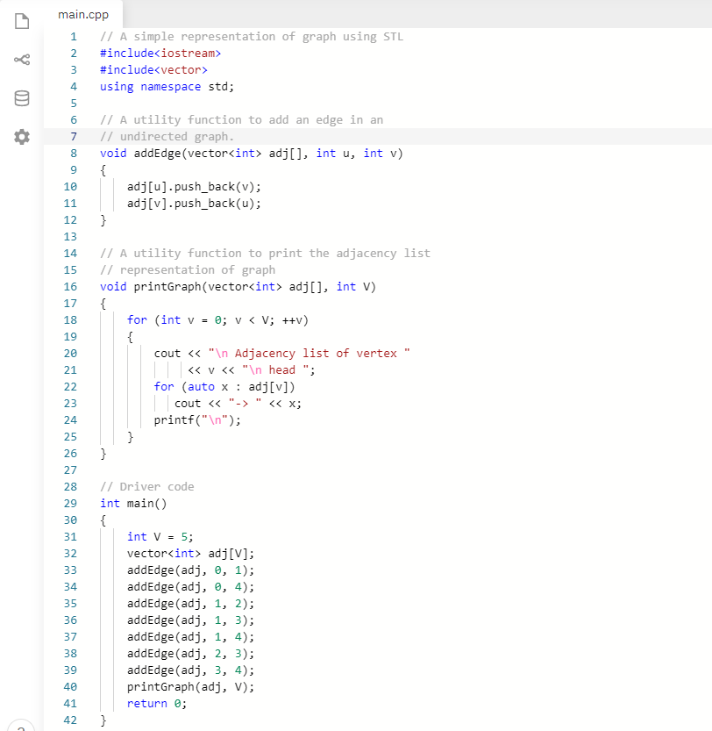
- Write and run Example 1 in an IDE and examine the program output.
- Verify the output of the Example 1 program. Does it match with Exercise 1? If not, explain your answer.
- Review the program code and identify the section of the code that produces the adjacency list for the graph and explain its functionality in the overall program.
- Given a graph, can a developer create a C++ program without evaluating the adjacency vertices?

Data Structure: struct
A data structure is a group of data elements grouped together under one name. These data elements, known as members, can have different types and different lengths. Data structures can be declared in C++ using the following syntax:
struct type_name {
member_type1 member_name1;
member_type2 member_name2;
member_type3 member_name3;
.
.
} object_names;
Where type_name is a name for the structure type, object_name can be a set of valid identifiers for objects that have the type of this structure. Within braces {}, there is a list with the data members, each one is specified with a type and a valid identifier as its name.
Example:
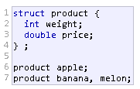
This declares a structure type, called product, and defines it having two members: weight and price, each of a different fundamental type. This declaration creates a new type (product), which is then used to declare three objects (variables) of this type: apple, banana, and melon. Note how once product is declared, it is used just like any other type.
Right at the end of the struct definition, and before the ending semicolon (;), the optional field object_names can be used to directly declare objects of the structure type. For example, the structure objects apple, banana, and melon can be declared at the moment the data structure type is defined.

Class in C++
A class is used to specify the form of an object and it combines data representation and methods for manipulating that data into one neat package. The data and functions within a class are called members of the class. A class definition starts with the keyword class followed by the class name; and the class body, enclosed by a pair of curly braces. A class definition must be followed either by a semicolon or a list of declarations. For example, we defined the Box data type using the keyword class as follows –
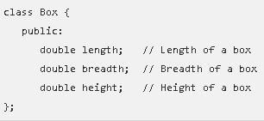
The keyword public determines the access attributes of the members of the class that follows it. A public member can be accessed from outside the class anywhere within the scope of the class object. You can also specify the members of a class as private or protected.
- Refer to the below graph, Graph 2, and complete the following tasks:
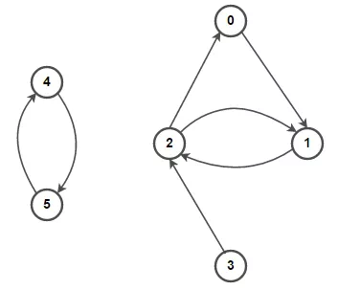
Graph 2: Directed simple graph

- Identify the vertices and edges of Graph 2.

- Determine the adjacency list and matrix for Graph 2.

Vertex | 0 | 1 | 2 | 3 | 4 | 5
0
1
2
3
4
5

- Input the example 2 C++ program in an IDE and run the program.
Example 2: C++ program representing adjacency list of a graph.
#include <iostream>
using namespace std;

// Data structure to store Adjacency list nodes
struct Node {
int val;
Node* next;
};

// Data structure to store graph edges
struct Edge {
int src, dest;
};

class Graph
{
// Function to allocate new node of Adjacency List
Node* getAdjListNode(int dest, Node* head)
{
Node* newNode = new Node;
newNode->val = dest;

// point new node to current head
newNode->next = head;

return newNode;
}

int N; // number of nodes in the graph

public:

// An array of pointers to Node to represent
// adjacency list
Node **head;

// Constructor
Graph(Edge edges[], int n, int N)
{
// allocate memory
head = new Node*[N]();
this->N = N;

// initialize head pointer for all vertices
for (int i = 0; i < N; i++)
head[i] = nullptr;

// add edges to the directed graph
for (unsigned i = 0; i < n; i++)
{
int src = edges[i].src;
int dest = edges[i].dest;

// insert in the beginning
Node* newNode = getAdjListNode(dest, head[src]);

// point head pointer to new node
head[src] = newNode;

// Uncomment below lines for undirected graph

/*
newNode = getAdjListNode(src, head[dest]);

// change head pointer to point to the new node
head[dest] = newNode;
*/
}
}

// Destructor
~Graph() {
for (int i = 0; i < N; i++)
delete[] head[i];

delete[] head;
}
};

// print all neighboring vertices of given vertex
void printList(Node* ptr)
{
while (ptr != nullptr)
{
cout << " -> " << ptr->val << " ";
ptr = ptr->next;
}
cout << endl;
}

// Graph Implementation in C++ without using STL
int main()
{
// array of graph edges as per above diagram.
Edge edges[] =
{
// pair (x, y) represents edge from x to y
{ 0, 1 }, { 1, 2 }, { 2, 0 }, { 2, 1 },
{ 3, 2 }, { 4, 5 }, { 5, 4 }
};

// Number of vertices in the graph
int N = 6;

// calculate number of edges
int n = sizeof(edges)/sizeof(edges[0]);

// construct graph
Graph graph(edges, n, N);

// print adjacency list representation of graph
for (int i = 0; i < N; i++)
{
// print given vertex
cout << i << " --";

// print all its neighboring vertices
printList(graph.head[i]);
}

return 0;
}

- Review above program of Graph 2 and determine the areas of the program that produce the representation of the graph components: vertices, edges and adjacency.
- Compare the program adjacency list to your result in Exercise 2 Question B.
- Can a developer create this program without pre-determining the adjacency list?
- Compare to a simple graph program, such as Exercise 2 program, what areas of the program produce edge directions? Explain the code functionality in the overall program.

- Refer to the below graph, Graph 3, and complete the following tasks:
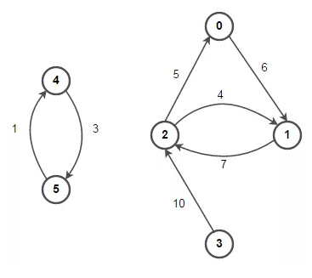
Graph 3: Directed Weighted Graph
- Identify the vertices and edges in Graph 3.

- Derive an adjacency list and a matrix for Graph 3.
Adjacency:

Vertex | 0 | 1 | 2 | 3 | 4 | 5
0
1
2
3
4
5

- Input the following C++ program in IDE, run the program and answer the following questions.
#include <iostream>
using namespace std;

// Data structure to store Adjacency list nodes
struct Node {
int val, cost;
Node* next;
};

// Data structure to store graph edges
struct Edge {
int src, dest, weight;
};

class Graph
{
// Function to allocate new node of Adjacency List
Node* getAdjListNode(int value, int weight, Node* head)
{
Node* newNode = new Node;
newNode->val = value;
newNode->cost = weight;

// point new node to current head
newNode->next = head;

return newNode;
}

int N; // number of nodes in the graph

public:

// An array of pointers to Node to represent
// adjacency list
Node **head;

// Constructor
Graph(Edge edges[], int n, int N)
{
// allocate memory
head = new Node*[N]();
this->N = N;

// initialize head pointer for all vertices
for (int i = 0; i < N; ++i)
head[i] = nullptr;

// add edges to the directed graph
for (unsigned i = 0; i < n; i++)
{
int src = edges[i].src;
int dest = edges[i].dest;
int weight = edges[i].weight;

// insert in the beginning
Node* newNode = getAdjListNode(dest, weight, head[src]);

// point head pointer to new node
head[src] = newNode;

// Uncomment below lines for undirected graph

/*
newNode = getAdjListNode(src, weight, head[dest]);

// change head pointer to point to the new node
head[dest] = newNode;
*/
}
}

// Destructor
~Graph() {
for (int i = 0; i < N; i++)
delete[] head[i];

delete[] head;
}
};

// print all neighboring vertices of given vertex
void printList(Node* ptr, int i)
{
while (ptr != nullptr)
{
cout << "(" << i << ", " << ptr->val
<< ", " << ptr->cost << ") ";

ptr = ptr->next;
}

cout << endl;
}

// Graph Implementation in C++ without using STL
int main()
{
// array of graph edges as per above diagram.
Edge edges[] =
{
// (x, y, w) -> edge from x to y having weight w
{ 0, 1, 6 }, { 1, 2, 7 }, { 2, 0, 5 }, { 2, 1, 4 },
{ 3, 2, 10 }, { 4, 5, 1 }, { 5, 4, 3 }
};

// Number of vertices in the graph
int N = 6;

// calculate number of edges
int n = sizeof(edges)/sizeof(edges[0]);

// construct graph
Graph graph(edges, n, N);

// print adjacency list representation of graph
for (int i = 0; i < N; i++)
{
// print all neighboring vertices of vertex i
printList(graph.head[i], i);
}

return 0;
}

- Compare the program adjacency list to your result in Exercise 3 Question B.
- Can a developer create this program without pre-determining the adjacency list or a matrix?
- Compare to a unweighted directed graph program, such as Exercise 2 program, what areas of Exercise 3 program produce the weighted edges? Explain the code functionality in the overall program.

Submit a document that contains answers and screen capture in Canvas (Unit 10 Lab).

